Student Activity
28 Resistance in a combination circuit

TASK
To determine the total effective resistance of a combination of resistors in series and parallel.

THEORY
In a circuit combining both parallel and series components, first calculate the total resistance of the resistors in parallel. Treat this calculated resistance as a single resistor in series with other individual resistors or combinations to find the total effective resistance of the complete circuit.

EQUIPMENT
• power supply
• DC voltmeter (0–10 V) or voltage sensor
• DC ammeter (0–1 A) or current sensor
• 3 resistors of unknown resistance (resistors rated 2 W or more are suitable)
• connecting wires

ICT
Most current sensors have a 1 A range and are suitable for this experiment.
They are generally current-protected, but take care to check the manufacturer’s specifications, and use sensors with care.
Exceeding the maximum current rating will permanently damage an ammeter or sensor.
Sampling rate: As only comparative values are required, the default rates of your equipment or manual sampling are suitable.
Use a digital display to view and record instantaneous values.

NOTES ON METHOD
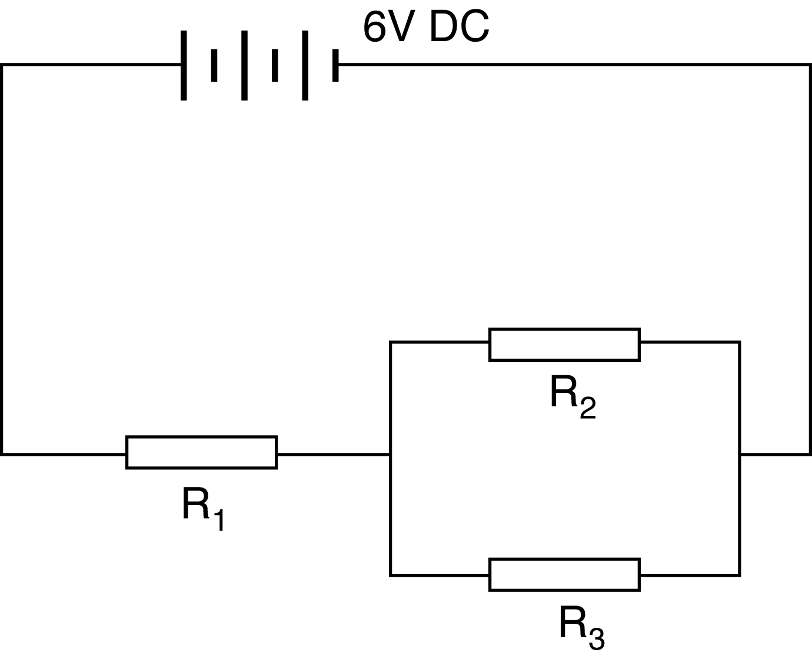
Connect a circuit using the three unknown resistors, as shown in the diagram.
Set the power supply to 6 V, turn it on, and measure the potential difference and current in the circuit for:
1. Each individual resistor.
2. The total of the two resistors in parallel.
3. The total potential difference and current in the circuit.
Record these results.

DATA & ANALYSIS
Summarise your results in a suitable table.
Use your results to calculate the value of each resistor and to determine the total effective resistance of the circuit.

CONCLUSION
Summarise your results for potential difference, current, and effective resistance for:
• each individual resistor
• the total for the pair of resistors in parallel
• the total combination circuit.

QUESTIONS
1. Describe or draw a flow chart of the method by which you determined the required values from your measurements.

